CONNECT TO WORK
Programme Manager Candidate Brief
London Borough of Tower Hamlets

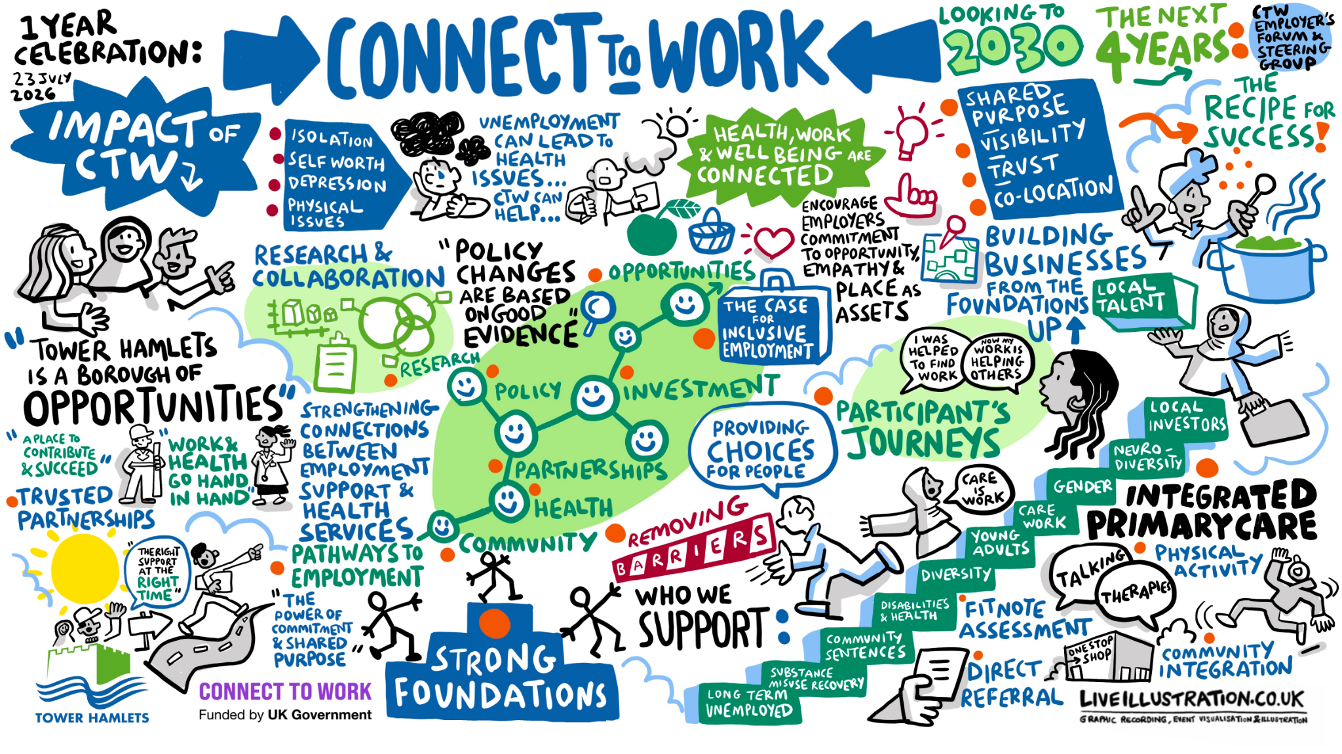

An Opportunity to Lead a Transformational Employment Programme
The London Borough of Tower Hamlets is seeking an exceptional Programme Manager to lead the delivery of Connect to Work, a flagship employment programme that sits at the heart of the Government's ambition to tackle economic inactivity and support disabled people and those with health conditions into sustainable employment. Delivered through Central London Forward, Connect to Work is funded by the Department for Work and Pensions and will run until March 2030. It will support more than 17,000 residents across central London over the next five years.
Tower Hamlets is one of London's most dynamic economies. Home to Canary Wharf, a thriving business base and major regeneration programmes, the borough generates significant employment opportunities. At the same time, many residents continue to face substantial barriers to work linked to disability, long-term health conditions, caring responsibilities, confidence, skills, or wider social and economic disadvantage.
Connect to Work has been designed to bridge that gap.
The programme will provide voluntary, personalised employment support for residents who are out of work due to disability, health conditions or complex barriers, as well as supporting individuals already in employment who are at risk of falling out of work. The programme uses a Supported Employment model, focused on helping people secure employment quickly and then providing the support needed to sustain and progress within their role.
For Tower Hamlets, Connect to Work represents a significant opportunity to strengthen economic inclusion, improve health outcomes, reduce inequality and ensure local residents can access the benefits of economic growth.

What Makes This Role Different?
This is not a traditional contract management role.
The Programme Manager will lead one of the borough's largest externally funded employment programmes, responsible for driving strategic partnerships, overseeing operational delivery, ensuring contractual compliance and performance, and shaping the future of work and health support within Tower Hamlets.
The role requires a leader who can operate confidently across multiple environments, from local authority services and health systems to employers, voluntary sector organisations and regional partnerships.
You will work closely with:
- Central London Forward as the programme's accountable body
- NHS and health partners
- Primary Care Networks and GP practices
- Voluntary and community sector organisations
- Employers across growth sectors
- Department for Work and Pensions stakeholders
- Internal council services including Employment & Skills, Adult Social Care and Public Health
Success will depend upon your ability to build trusted partnerships, create effective referral pathways, engage employers and develop a high-performing delivery team.

The Scale of the Programme
Connect to Work in Tower Hamlets
- Approximately 1,767 residents supported over the life of the programme
- Around 1,457 residents expected to enter the programme from economic inactivity or unemployment
- Around 310 residents expected to receive in-work support
- Delivery through to March 2030
- Approximately £7 million investment into employment support services
- A multidisciplinary workforce of almost 30 staff at peak delivery
The programme will include Employment Specialists, Team Leaders, Employer Engagement staff, programme support and management functions working together to deliver ambitious outcomes for residents and employers.

The Challenge
While performance and compliance are important, this role is fundamentally about people.
Many participants will have experienced long periods out of work, poor health, low confidence or previous negative experiences of employment support. The programme therefore requires a personalised approach that places the individual at the centre of service design and delivery. Research undertaken to support implementation across central London highlights the importance of trust-building, employer engagement and a genuine social model approach to disability and health-related employment support.
The successful candidate will need to create a culture that combines:
- High performance and accountability
- Compassionate and person-centred support
- Continuous improvement
- Strong partnership working
- A commitment to inclusion and social justice

What Success Looks Like
By the end of the programme, Connect to Work will have:
- Supported hundreds of residents with disabilities and health conditions into sustainable employment
- Reduced health-related economic inactivity
- Strengthened relationships between employment and health services
- Increased employer confidence in recruiting and retaining diverse talent
- Created a lasting supported employment infrastructure within the borough
- Enhanced opportunities for residents who have traditionally been excluded from the labour market
Most importantly, it will have helped local people secure greater independence, financial stability and improved wellbeing through good work.

Why Tower Hamlets?
Tower Hamlets has a strong track record of delivering innovative employment and skills programmes and is recognised for its commitment to inclusive growth and tackling inequality.
Connect to Work aligns directly with the council's wider ambitions around:
- Inclusive Economy
- Good Work
- Health Equity
- Community Wealth Building
- Social Mobility
- Resident-Focused Services
For the successful applicant, this is a rare opportunity to shape and lead a programme of genuine strategic significance, delivering measurable impact for residents while helping define the future of employment support in one of London's most ambitious boroughs.
If you are an experienced programme leader with a passion for inclusive employment, partnership working and delivering meaningful social impact, we would welcome your application.

